**PHENIKAA UNIVERSITY**

**SCHOOL OF COMPUTING**



**COURSE MODULE: SOFTWARE ARCHITECTURE**

**PROJECT TITLE: BUILDING A BUS TICKET BOOKING SYSTEM**

Instructor: ThS. Vũ Quang Dũng

Group: Nguyễn Minh Nguyệt (23010408)

Lò Bảo Duy (23010096)

Class: CSE703110-1-2-25(N02)

**Ha Noi, January 30, 2026**

CONTENTS

PREFACE 3

ACKNOWLEDGEMENTS 4

1. Executive Summary 5

2. Project Requirements & Goals 6

2.1 Core Functional Requirements 6

2.2 Key Quality Attributes (Architectural Goals – Non-functional Requirements) 7

2.3 Propose model of ASR 8

2.4 Use Case Modeling 9

3. Architectural Design & Implementation 11

3.1 Architectural Pattern: Event-Driven Architecture (EDA) 11

3.2 System Context Diagram (C4 Model) 12

3.3 Service Implementation Details 14

3.4 Inter-Service Communication 17

4. Testing & Verification 21

6. Conclusion & Reflection 32

6.1 Lessons Learned 32

6.2 Future Improvements 33

REFERENCES 34

# IMAGE CATALOG

Figure 1. Overall Use Case Diagram 14

Figure 2. Detailed Use Case Diagram 15

Figure 3. Level 1 - System Context Level 17

Figure 4. Level 2 - Container Level 18

Figure 5. Level 3 - Compoment Level 18

Figure 6. Level 4 - Code Level 19

Figure 7. Unit Test Booking_1 26

Figure 8.Unit Test Booking_2 27

Figure 9. Unit Test Booking_3 27

*Figure 10. Booking Note Test_1* 28

*Figure 11. Booking Note Test_2* 29

Figure 12. Booking Note Test_3 29

Figure 13. Bus Company List 30

Figure 14. Footer 31

[Figure 15. Bus ListFigure…………………………………………………...…30   
Figure 16. Seat Selection 32](#_Toc221353347)

Figure 17. QR Code 33

Figure 18. Booking Success 34

Figure 19. Nginx 34

Figure 20. Kafka 34

Figure 21. My Tickets_1 35

Figure 22. My Tickets_2 35

Figure 23. My Tickets_3 36

Figure 24. Docker Containers 36

# 

# PREFACE

In the context of the rapid development of information technology, the application of software systems to management and service delivery has become an inevitable trend across many areas of modern society. Particularly in the passenger transportation sector, the increasing demand for fast, convenient, and transparent ticket booking requires software systems not only to provide correct functionality but also to ensure scalability, reliability, high performance, and long-term maintainability.

The Software Architecture course plays an important role in equipping students with systematic thinking at the architectural level, including decomposing systems into independent components, selecting appropriate architectural styles, defining communication mechanisms among services, and optimizing quality attributes such as scalability, availability, and maintainability. Through this course, students are exposed to modern architectural approaches, especially Microservices Architecture, which enables the development of flexible and sustainable large-scale systems in real-world environments.

Based on these practical needs, our team selected the topic “**BUILDING A BUS TICKET BOOKING SYSTEM**” for this course project. The project focuses on requirement analysis, overall architectural design, service decomposition, inter-service communication mechanisms, and system deployment models. Through this process, the team has the opportunity to apply theoretical knowledge to solve real-world problems while strengthening architectural thinking and system design skills.

Although we have made considerable efforts to complete this project, due to limitations in time, experience, and research scope, shortcomings are unavoidable. Therefore, we sincerely look forward to receiving valuable feedback and suggestions from our instructor to further improve the quality of this project.

# ACKNOWLEDGEMENTS

We would like to express our sincere gratitude to TS. Vũ Quang Dũng, our lecturer for the Software Architecture course, for his dedicated guidance, valuable feedback, and professional support throughout the completion of this project. His knowledge and practical experience have greatly helped us develop a deeper understanding of architectural design principles and successfully accomplish this work.

We would also like to thank the School of Information Technology – Phenikaa University for providing favorable learning conditions, facilities, and academic resources that enabled us to conduct research and complete this project effectively.

Finally, we would like to thank our friends and classmates for their support, discussions, and constructive suggestions during the learning and development process. Their encouragement has been a significant motivation for us to complete our tasks.

Despite our best efforts, the project may still contain limitations and mistakes. We highly appreciate any comments and recommendations from our instructor to help us improve and gain better experience for future studies and projects.

# Executive Summary

This project aims to design and implement a Bus Ticket Booking System utilizing a Microservices Architecture with Event-Driven Communication patterns. The system enables passengers to search for bus routes, view available schedules, select seats, and complete ticket bookings with integrated payment processing.

The architectural approach decomposes the monolithic application into six distinct microservices: Identity Service, Fleet Service, Route Service, Schedule Service, Ticket Service, and an API Gateway. These services communicate through RESTful APIs for synchronous operations and Apache Kafka for asynchronous event-driven messaging. Redis is employed for distributed seat locking to handle concurrent booking scenarios.

The final achievement is a fully functional bus ticket booking platform that demonstrates:

High Scalability through service decomposition and horizontal scaling capabilities

Loose Coupling via event-driven communication patterns

Real-time Seat Availability using Redis distributed locks

Reliable Payment Processing with webhook integration (SePay)

Responsive User Experience through two client applications (Customer Portal and Admin Dashboard)

# Project Requirements & Goals

This section defines the scope and the key architectural drivers for the project.

## 2.1 Core Functional Requirements

|  |  |
| --- | --- |
| **ID** | **Description** |
| **FR-01** | The system must allow users to register and authenticate using email/username and password with JWT-based security. |
| **FR-02** | The system must allow users to search for available bus routes by departure station, arrival station, and travel date. |
| **FR-03** | The system must display available bus schedules for a selected route, including departure time, vehicle information, and pricing. |
| **FR-04** | The system must show real-time seat availability for each vehicle schedule, with seat types (Standard, VIP, Luxury) and pricing. |
| **FR-05** | The system must allow users to select and temporarily lock seats during the booking process to prevent double booking. |
| **FR-06** | The system must integrate with payment gateway (SePay) for processing ticket payments via bank transfer/QR code. |
| **FR-07** | The system must confirm bookings and update ticket status upon successful payment verification via webhook. |
| **FR-08** | The system must allow users to view their booking history and cancel tickets with valid reasons. |
| **FR-09** | The system must provide an admin dashboard for managing bus companies, vehicles, routes, stations, and schedules. |
| **FR-10** | The system must send notifications to users upon booking confirmation or cancellation. |

## 2.2 Key Quality Attributes (Architectural Goals – Non-functional Requirements)

The following quality attributes serve as the primary architectural drivers for the system design:

|  |  |  |
| --- | --- | --- |
| **Quality Attribute** | **Description** | **Target Metric** |
| **Scalability** | The system must handle a high number of concurrent users during peak booking hours. | Support 10,000+ concurrent active users |
| **Availability** | The system must maintain high uptime and handle service failures gracefully. | 99.5% uptime with graceful degradation |
| **Performance** | API response times must be optimized for user experience. | < 500ms for seat availability queries |
| **Consistency** | Seat booking operations must be consistent to prevent double bookings. | Zero double-booking incidents |
| **Modifiability** | The architecture must allow adding new features (e.g., chatbot, reviews) without major refactoring. | New service deployment within hours |
| **Security** | User authentication and payment data must be protected. | JWT-based auth, secure webhook validation |

## 2.3 Propose model of ASR

**ASR: Real-Time Seat Locking (Consistency)**

|  |  |
| --- | --- |
| **Component** | **Details** |
| Statement | When a user initiates booking for a seat, the seat must be temporarily locked for 5 minutes to prevent other users from booking the same seat. |
| Impact | This drives the implementation of Redis-based distributed locking mechanism. The lock ensures atomicity across multiple service instances and provides TTL-based automatic release. |

**ASR: Payment Integration Reliability**

|  |  |
| --- | --- |
| **Component** | **Details** |
| Statement | Payment confirmation must be processed reliably through external payment gateway webhooks, with idempotent processing to handle duplicate notifications. |
| Impact | This requires implementing idempotent webhook handlers, storing payment transaction IDs (SePay ID), and using Kafka events to decouple payment processing from ticket confirmation. |

## 2.4 Use Case Modeling

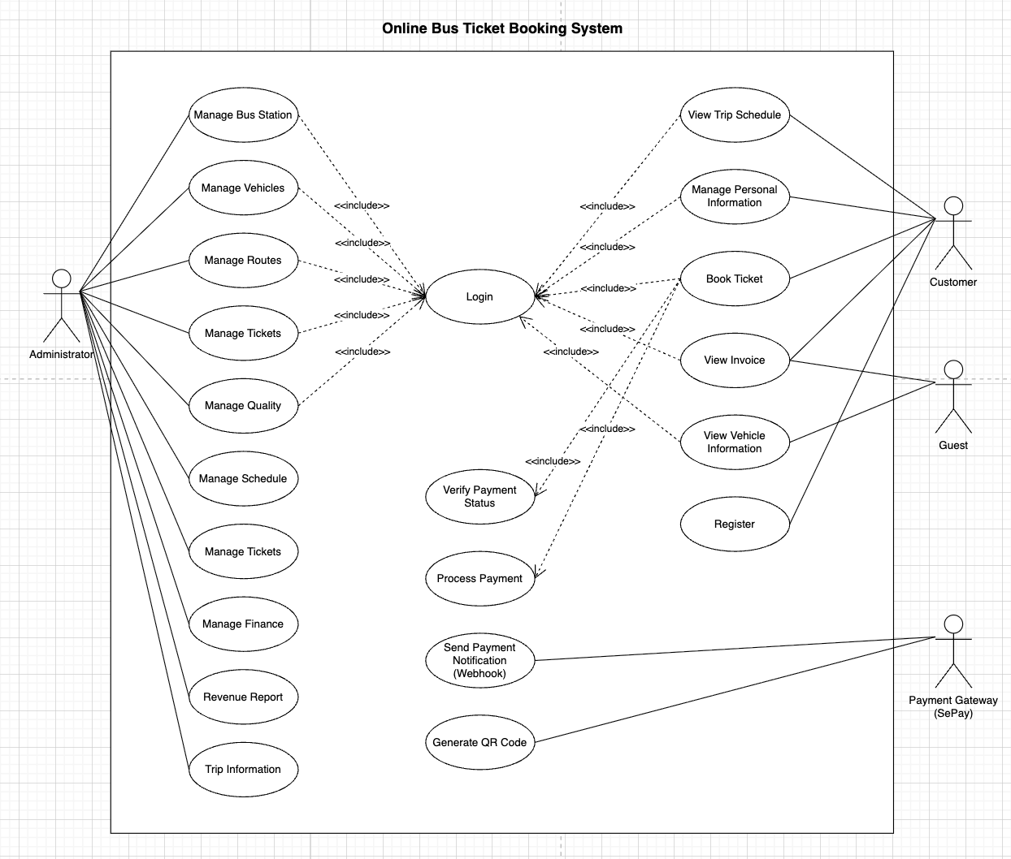

Figure 1. Overall Use Case Diagram

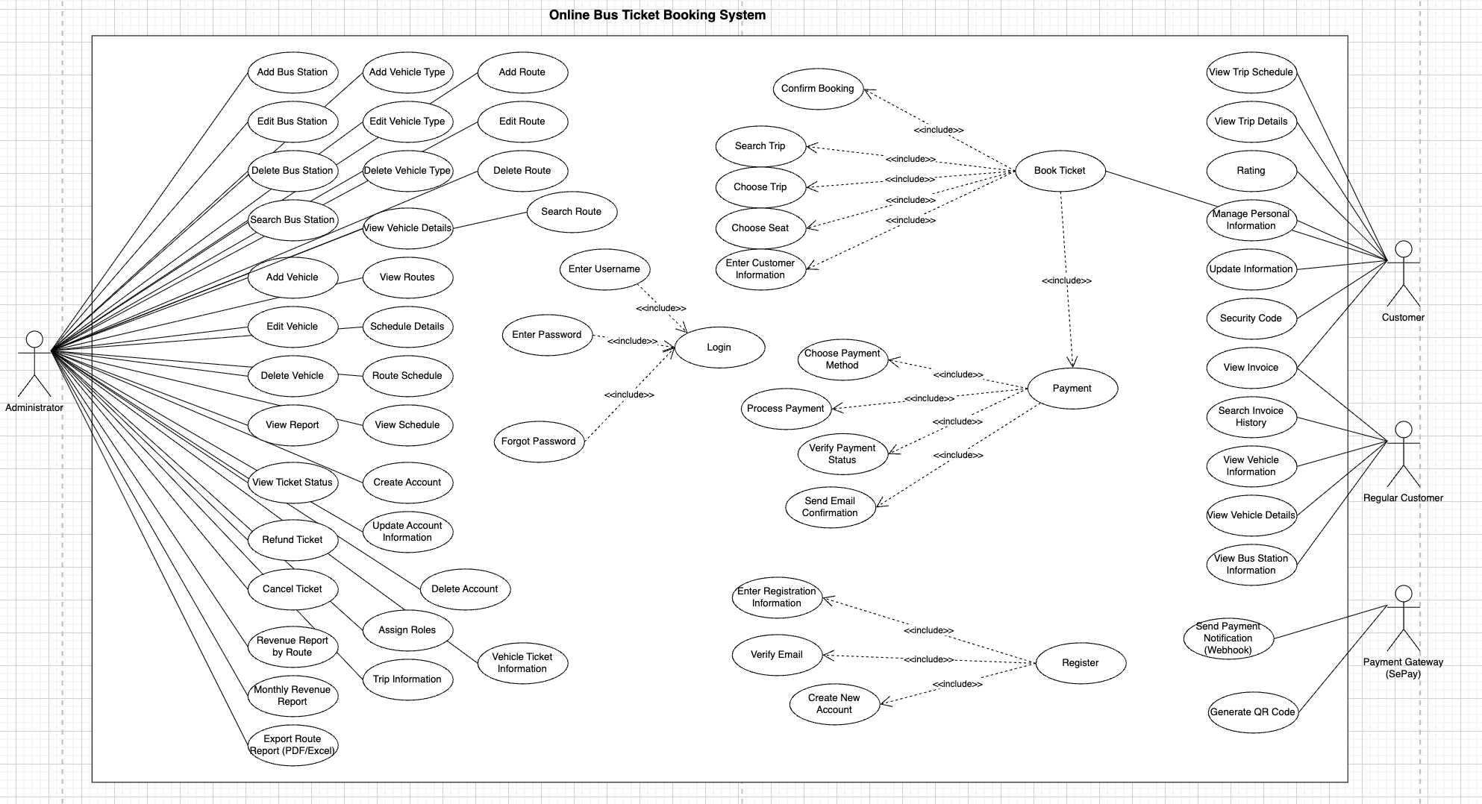

Figure 2. Detailed Use Case Diagram

**Analysis Diagrams**

To clarify the analyzed requirements and visually model the system, this chapter uses UML analysis diagrams to describe the behavior, structure, and interactions among components in the online bus ticket booking system.

# Architectural Design & Implementation

## 3.1 Architectural Pattern: Event-Driven Architecture (EDA)

The system implements Microservices Architecture combined with Event-Driven Architecture (EDA) patterns. This hybrid approach provides:

* Service Decomposition: The domain is decomposed into bounded contexts, each implemented as an independent microservice with its own database (Database-per-Service pattern).
* API Gateway Pattern: A centralized gateway handles request routing, authentication, and cross-cutting concerns.
* Event-Driven Communication: Services communicate asynchronously via Kafka for operations that don't require immediate response (e.g., payment confirmation, seat status updates).
* Distributed Locking: Redis provides distributed locks for critical sections (seat reservation) across service instances.

**Architectural Rationale:**

|  |  |
| --- | --- |
| **Pattern** | **Justification** |
| **Microservices** | Enables independent deployment, scaling, and technology choices per service. Supports team autonomy and fault isolation. |
| **API Gateway** | Single entry point simplifies client integration, enables centralized security, and provides routing flexibility. |
| **Event-Driven** | Decouples services temporally, improving resilience. Payment and notification operations benefit from async processing. |
| **Redis Locking** | Essential for maintaining consistency in concurrent seat booking scenarios across multiple service instances. |
| **Database-per-Service** | Each service owns its data, enabling independent schema evolution and reducing coupling. |

## 3.2 System Context Diagram (C4 Model)

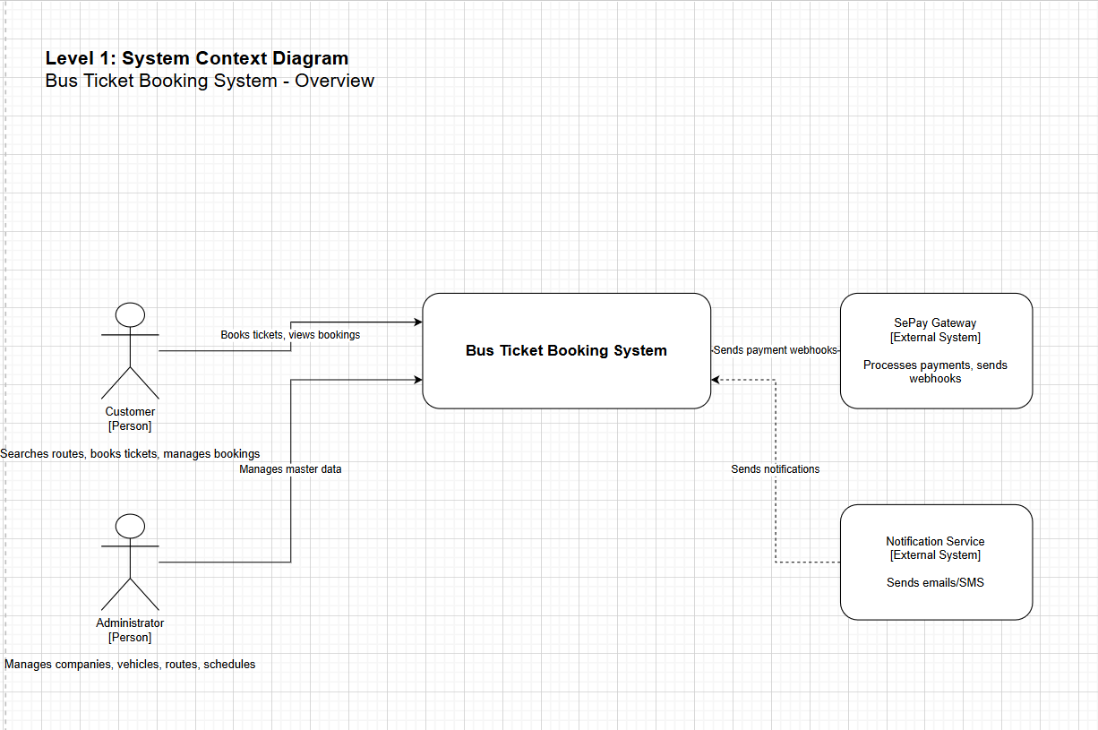

Figure 3. Level 1 - System Context Level

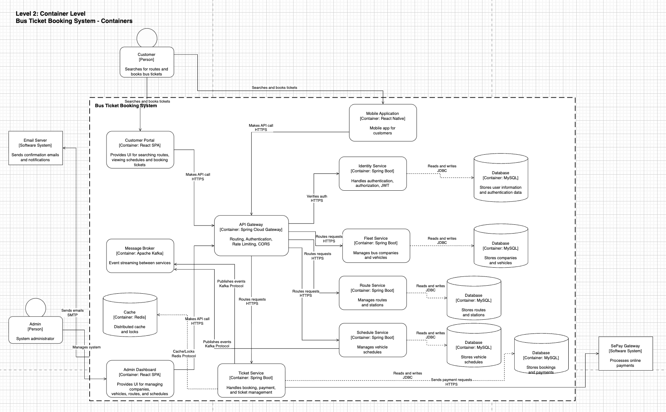

Figure 4. Level 2 - Container Level

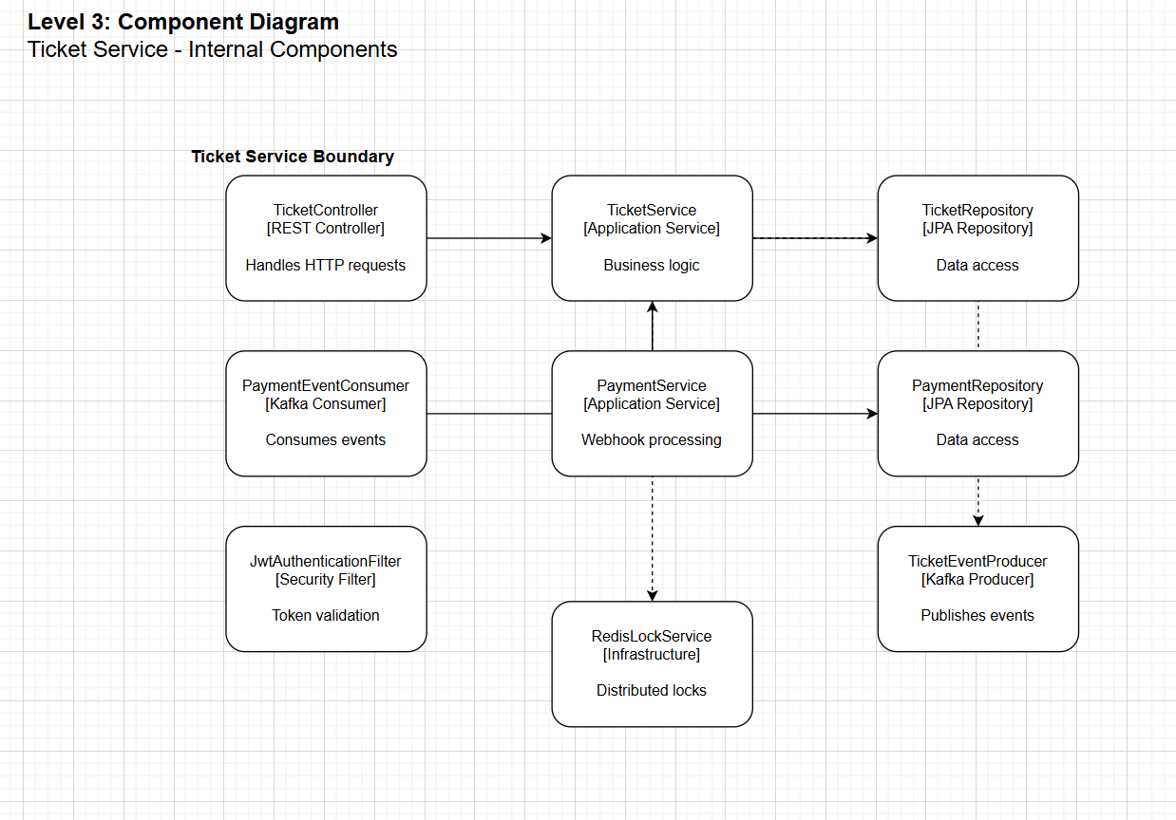

Figure 5. Level 3 - Compoment Level

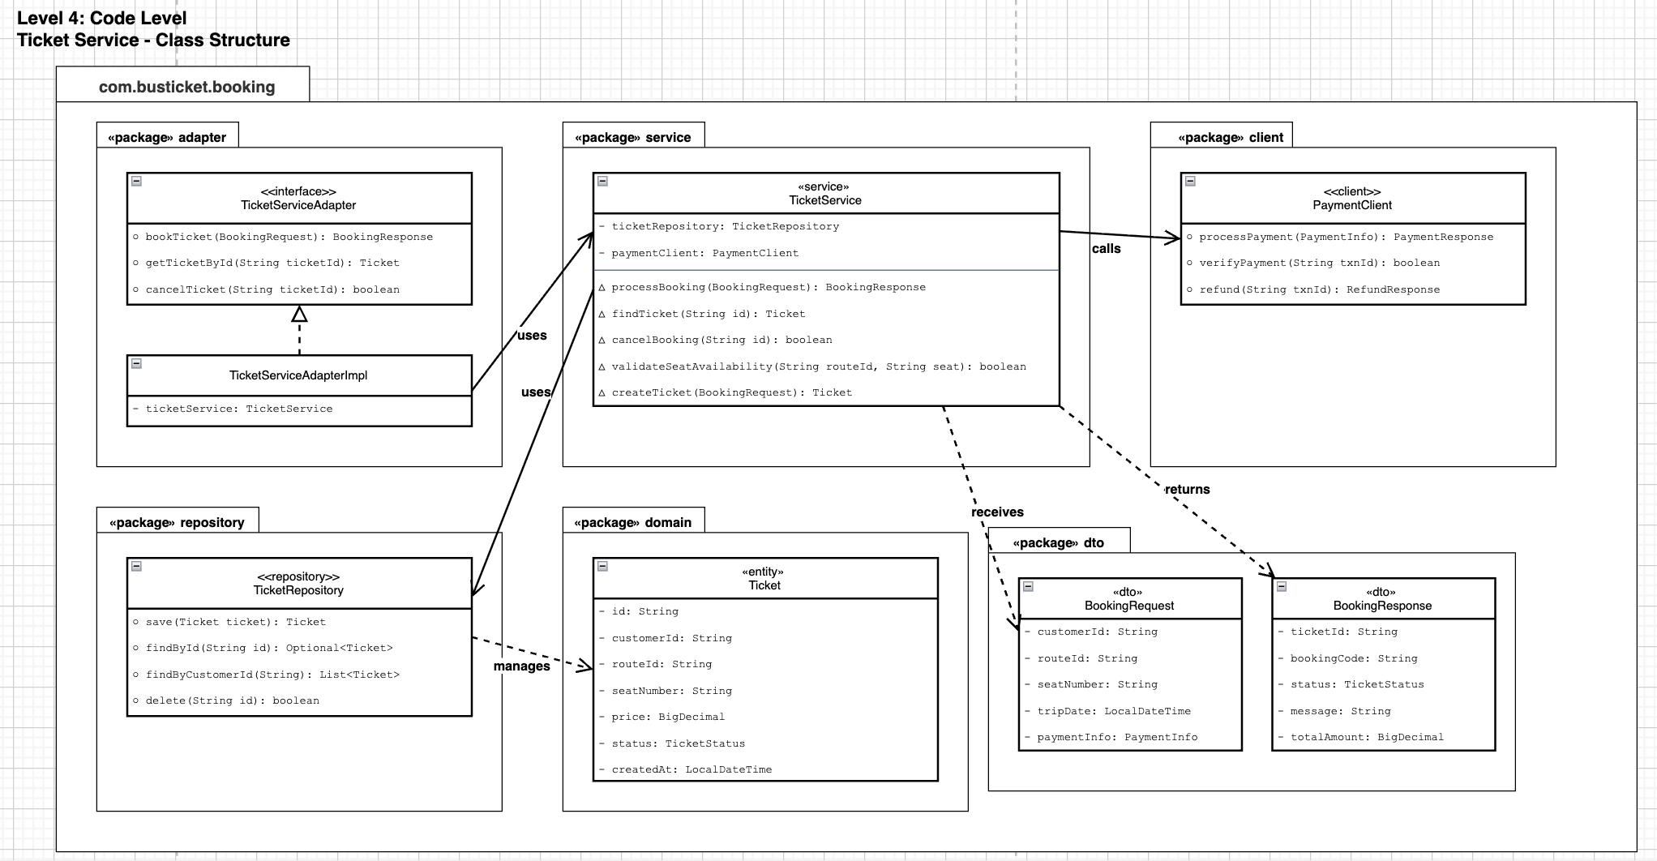  
Figure 6. Level 4 - Code Level

## 3.3 Service Implementation Details

Each microservice follows a Clean Architecture structure with clear separation of concerns:

service/

├── application/ # Use cases and application services

├── domain/

│ ├── model/ # Domain entities (JPA entities)

│ └── repository/ # Repository interfaces

├── infrastructure/

│ ├── config/ # Configuration classes

│ ├── exception/ # Exception handlers

│ ├── logging/ # Structured logging

│ ├── messaging/ # Kafka producers/consumers

│ ├── security/ # JWT filters, authentication

│ └── service/ # Infrastructure services (Redis)

└── presentation/

├── controller/ # REST controllers

└── dto/ # Request/Response DTOs

**Identity Service:**

Handles user authentication and authorization with JWT tokens.

|  |  |  |
| --- | --- | --- |
| **Endpoint** | **Method** | **Description** |
| **/auth/register** | POST | User registration with validation |
| **/auth/login** | POST | Authentication, returns JWT token |
| **/auth/logout** | POST | Token invalidation |
| **/auth/profile** | GET | Retrieve current user profile |

**Fleet Service:**

Manages bus companies, vehicles, and seat configurations.

|  |  |  |
| --- | --- | --- |
| **Endpoint** | **Method** | **Description** |
| **/bus-companies** | GET/POST | List/Create bus companies |
| **/bus-companies/:id** | GET/PUT/DELETE | CRUD operations on specific company |
| **/vehicles** | GET/POST | List/Create vehicles with company association |
| **/seats/vehicle/:vehicleId** | GET | Get all seats for a vehicle |

**Route Service:**

Handles geographic routing between stations.

|  |  |  |
| --- | --- | --- |
| **Endpoint** | **Method** | **Description** |
| **/stations** | GET/POST | List/Create stations with location data |
| **/routes** | GET/POST | List/Create routes with departure/arrival stations |

**Schedule Service:**

Manages vehicle departure schedules.

|  |  |  |
| --- | --- | --- |
| **Endpoint** | **Method** | **Description** |
| **/vehicle-schedules** | GET/POST | List/Create schedules |
| **/vehicle-schedules?routeId=X** | GET | Filter schedules by route |

**Ticket Service:**

Orchestrates the booking lifecycle with Redis locking and Kafka events.

|  |  |  |
| --- | --- | --- |
| **Endpoint** | **Method** | **Description** |
| **/tickets** | POST | Create ticket (acquires Redis lock) |
| **/tickets/user/me** | GET | Get current user's tickets |
| **/tickets/:id** | PUT | Update ticket (cancel, etc.) |
| **/tickets/webhook/sepay** | POST | Receive SePay payment webhook |

## 3.4 Inter-Service Communication

The system employs both synchronous and asynchronous communication patterns:

**Synchronous Communication (REST via API Gateway):**

All client requests pass through the API Gateway, which routes to appropriate backend services:

|  |  |
| --- | --- |
| **Route Pattern** | **Target Service** |
| **/api/auth/\*\*** | Identity Service (8081) |
| **/api/bus-companies/\*\*** | Fleet Service (8082) |
| **/api/vehicles/\*\*** | Fleet Service (8082) |
| **/api/seats/\*\*** | Fleet Service (8082) |
| **/api/routes/\*\*** | Route Service (8083) |
| **/api/stations/\*\*** | Route Service (8083) |
| **/api/vehicle-schedules/\*\*** | Schedule Service (8084) |
| **/api/tickets/\*\*** | Ticket Service (8085) |

**Asynchronous Communication (Kafka Events):**

|  |  |  |  |
| --- | --- | --- | --- |
| **Topic** | **Producer** | **Consumer** | **Event Purpose** |
| **payment-events** | Ticket Service | Ticket Service | Payment status changes trigger ticket confirmation |
| **ticket-events** | Ticket Service | Fleet Service | Ticket booking/cancellation updates seat status |
| **notification-events** | Ticket Service | (Notification Service) | User notifications for booking confirmation |

**Event Flow Diagram:**

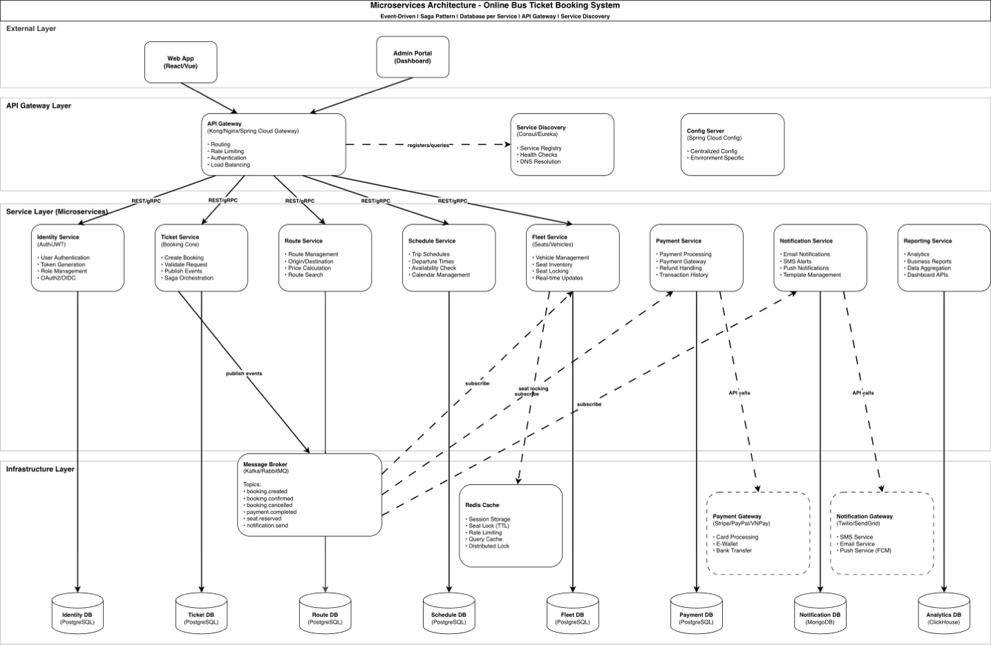

*Figure 5. Event Flow Diagram*

The diagram show the flow:

* The system adopts a Microservices Architecture combined with an API Gateway and Event-Driven communication. All client requests from the Web App and Admin Portal pass through the API Gateway, which manages authentication, routing, rate limiting, and load balancing before forwarding them to the appropriate services.
* Services communicate synchronously via REST/gRPC for real-time operations and asynchronously through a message broker (Kafka/RabbitMQ) for cross-service workflows, ensuring loose coupling and scalability. The ticket booking process follows the Saga pattern: the Ticket Service creates a booking, Fleet Service locks seats using Redis, Payment Service processes payment, and Notification Service sends confirmations.
* Each microservice maintains its own database, while Redis supports caching and distributed locking. This architecture enhances scalability, fault isolation, and maintainability.

**Redis Distributed Locking Flow:**

The seat locking mechanism prevents double-booking race conditions:

|  |  |  |
| --- | --- | --- |
| **Step** | **Action** | **Redis Operation** |
| **1** | User selects seat | SETNX seat_lock:scheduleId:seatId LOCKED EX 300 |
| **2** | Lock acquired | Returns true if key didn't exist |
| **3** | Lock denied | Returns false if seat already locked |
| **4** | Payment success | DEL seat_lock:scheduleId:seatId |
| **5** | TTL expiration | Lock auto-releases after 5 minutes if payment abandoned |

# Testing & Verification

The following verification scenarios demonstrate the system's core functionality and architectural goals.

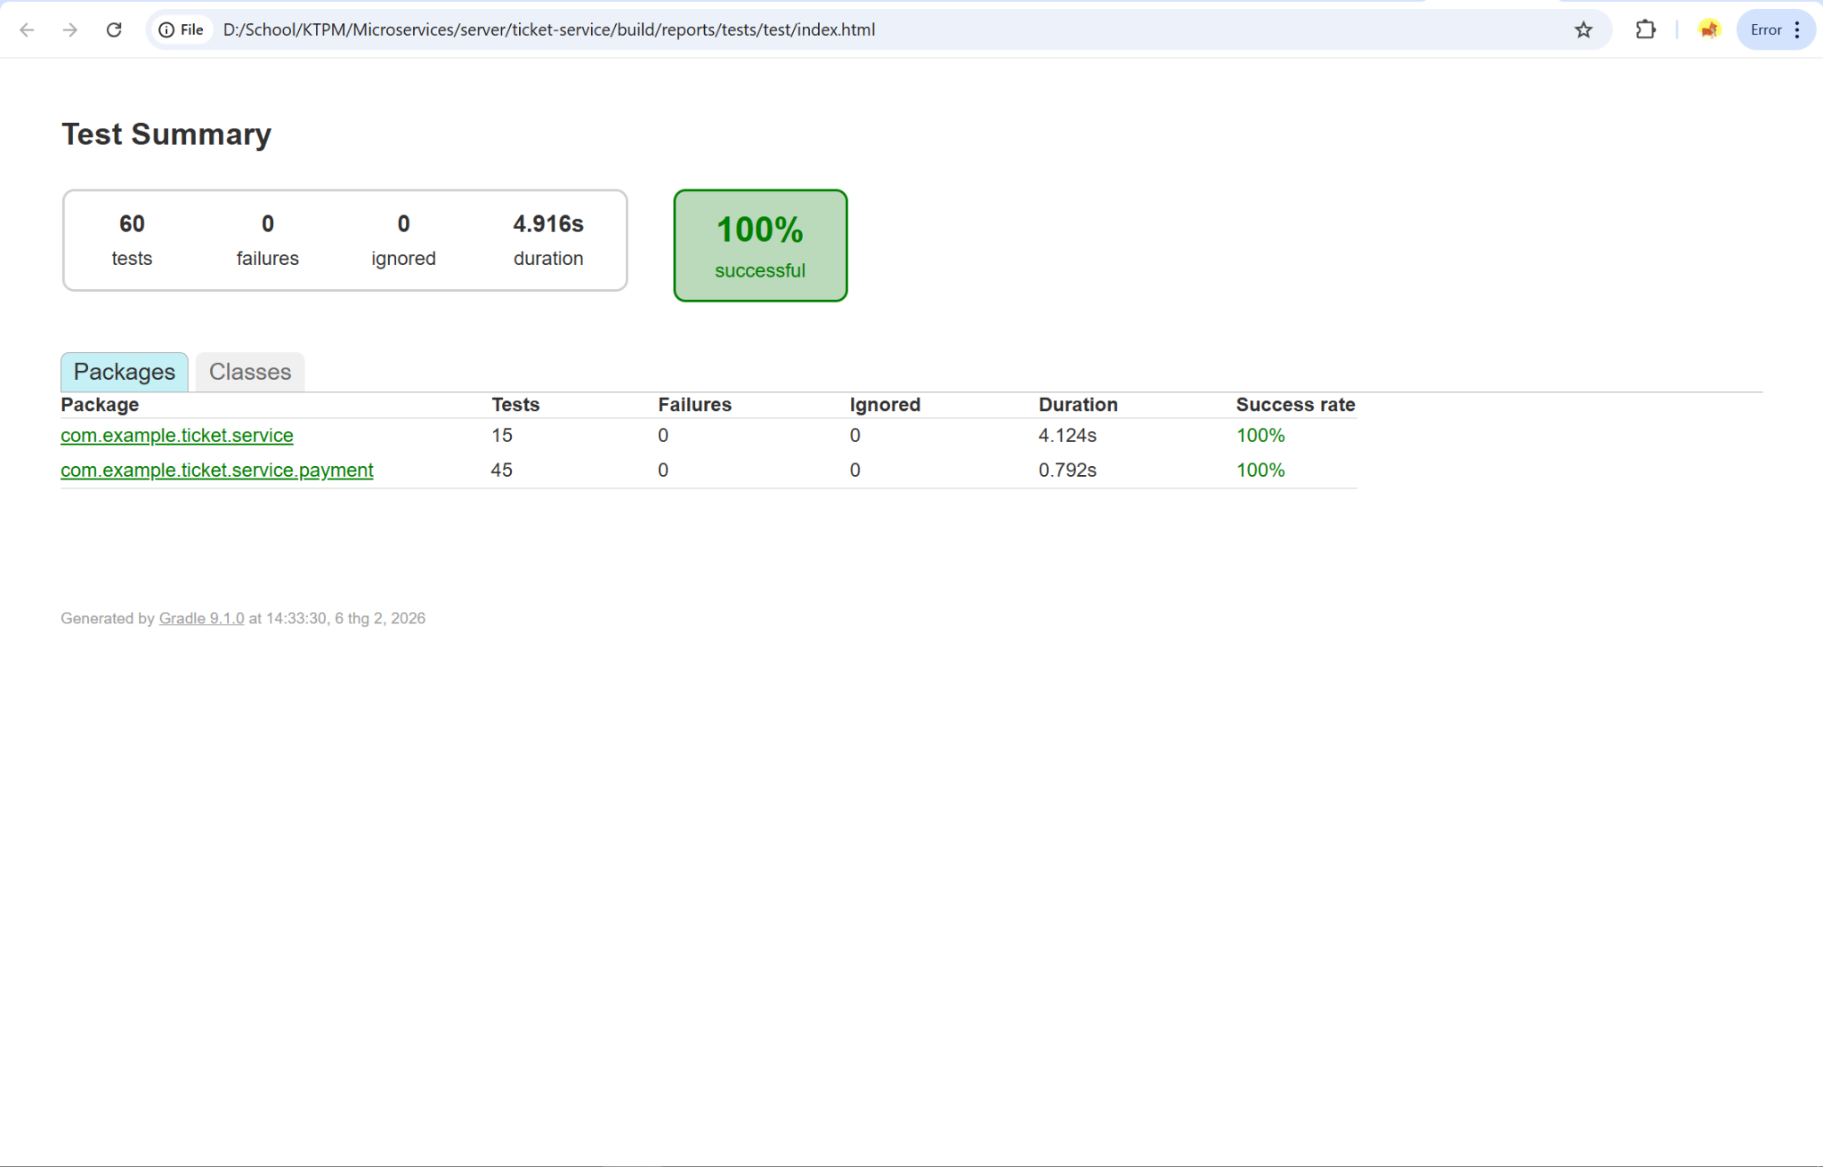

Figure 7. Unit Test Booking_1

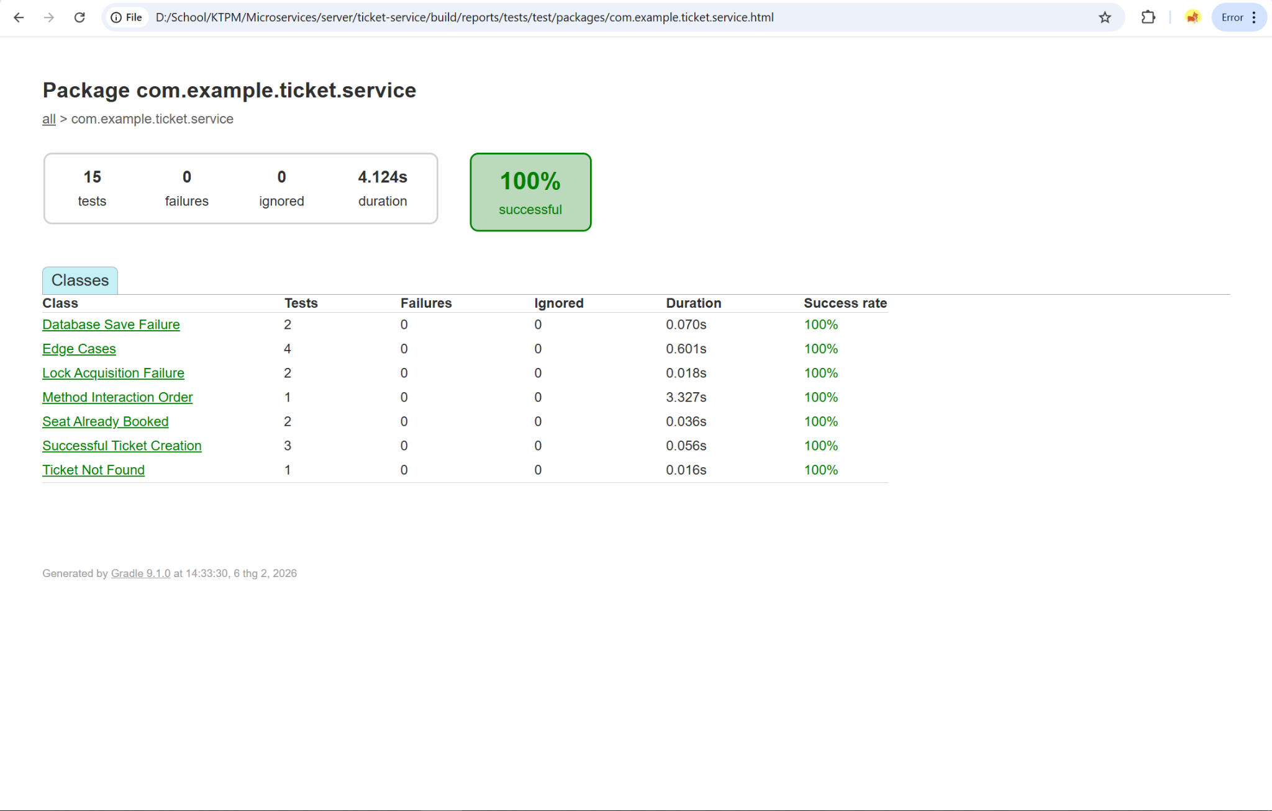

Figure 8.Unit Test Booking_2

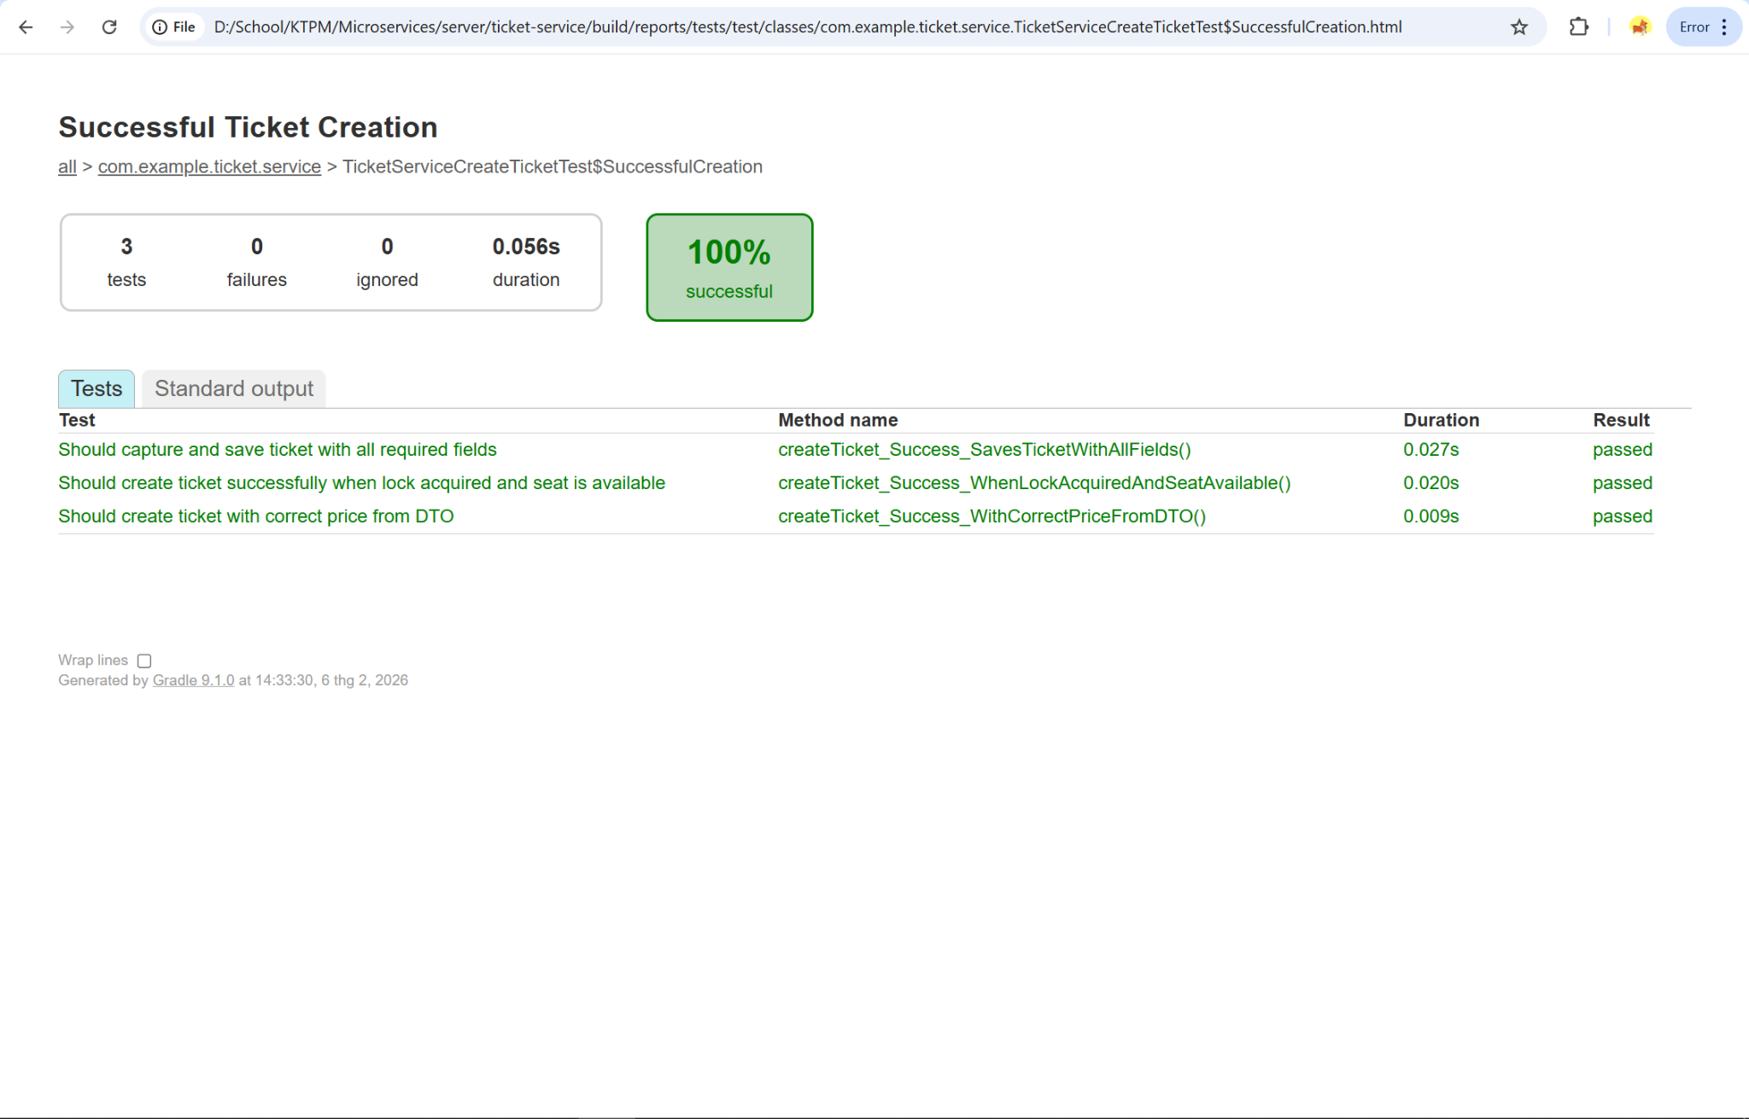

Figure 9. Unit Test Booking_3

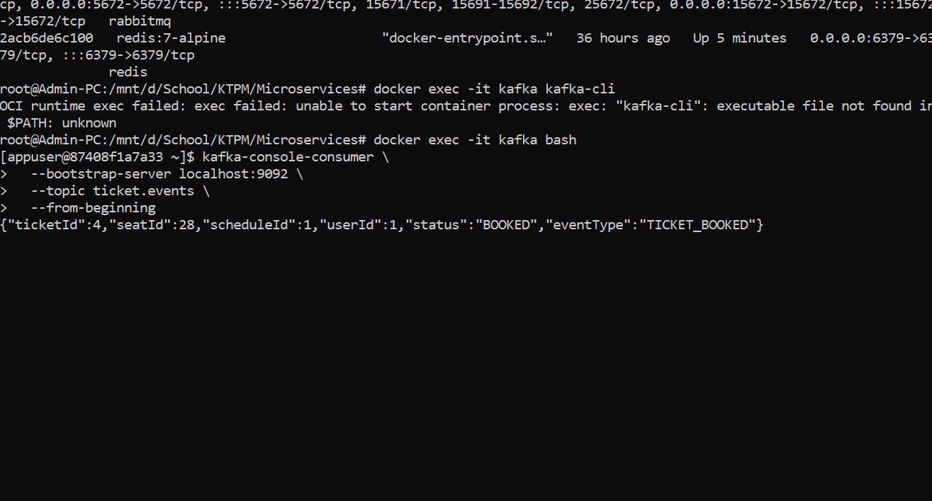 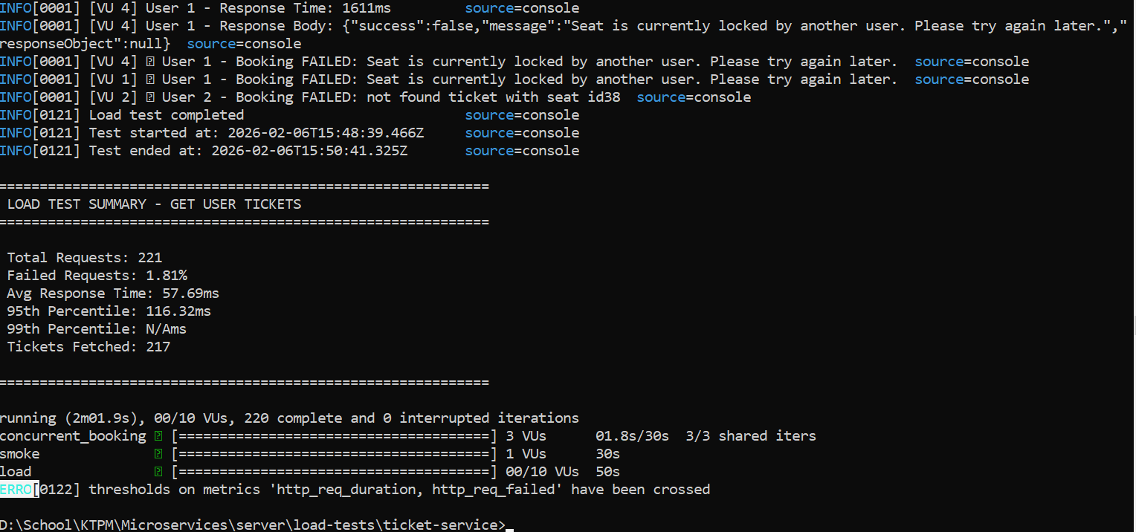

*Figure 10. Booking Note Test_1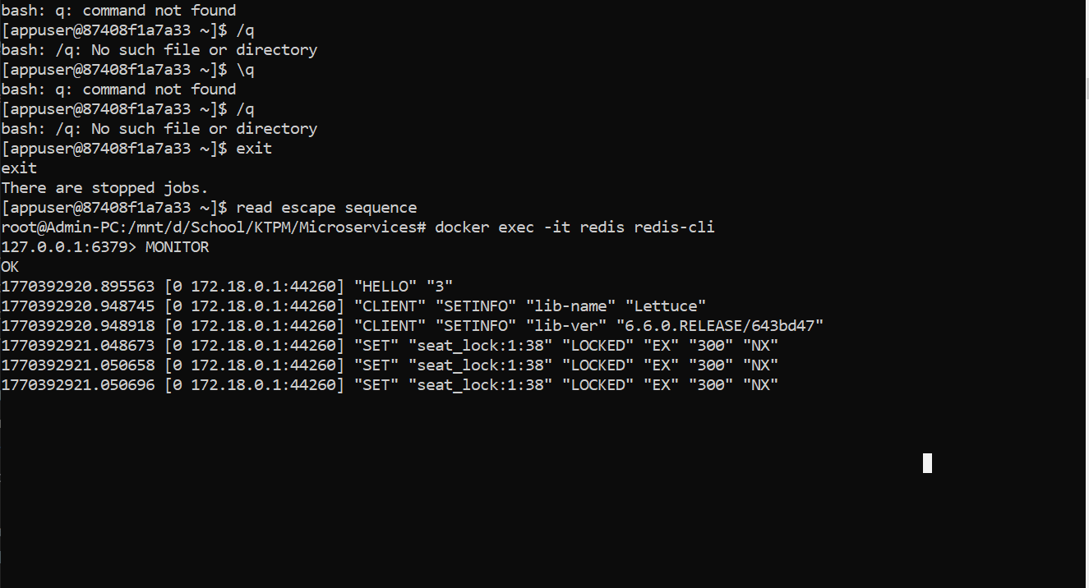*

*Figure 11. Booking Note Test_2*

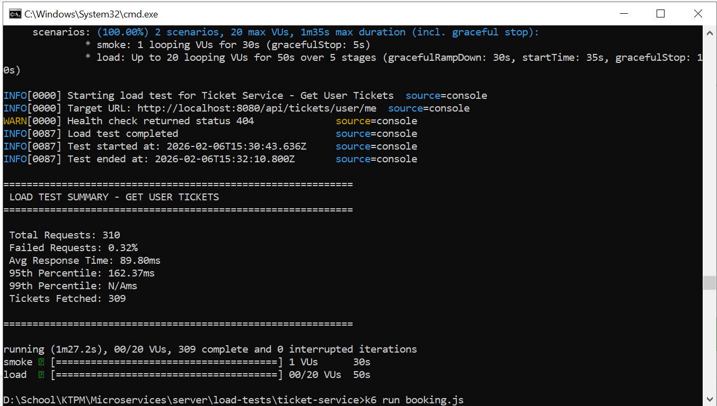

Figure 12. Booking Note Test_3

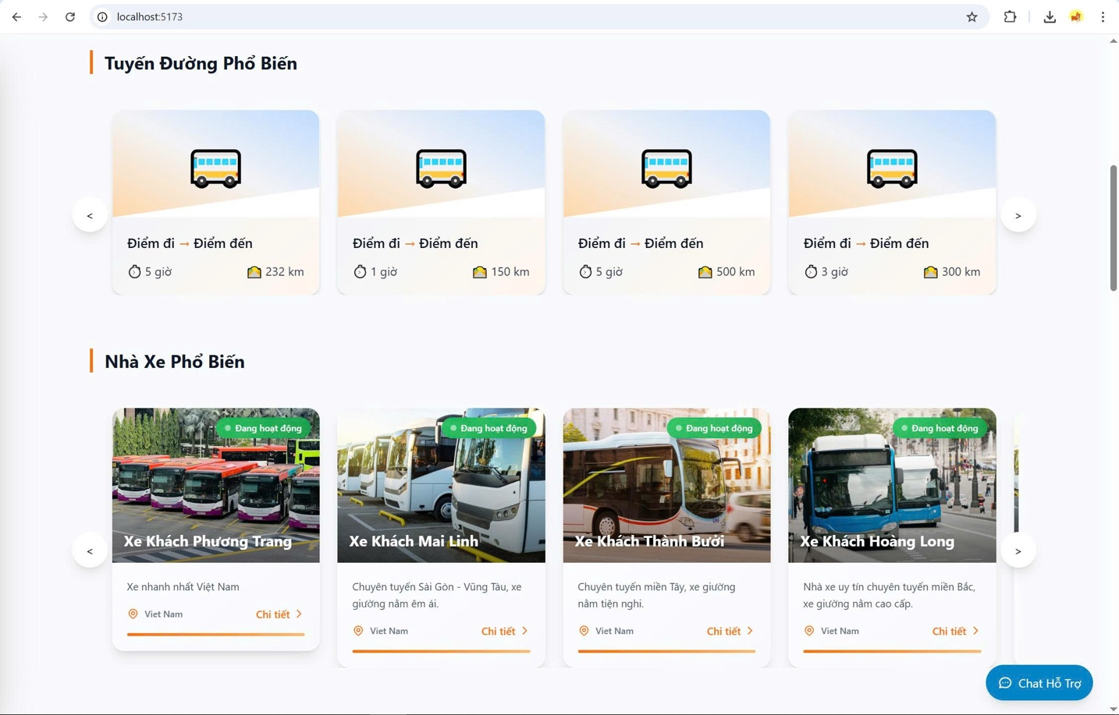

Figure 13. Bus Company List

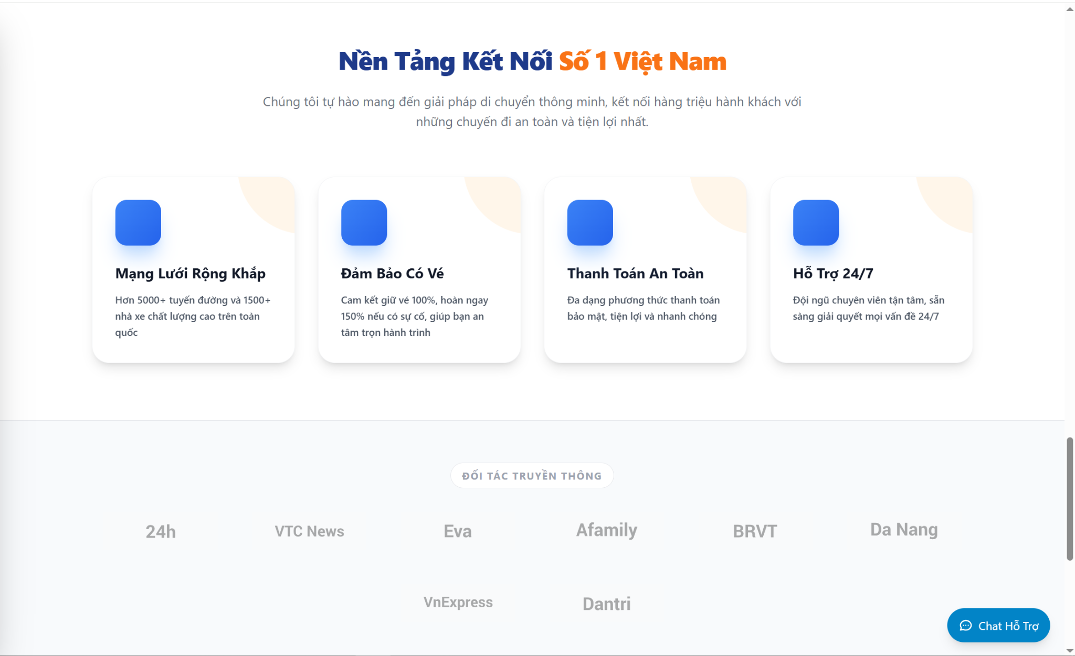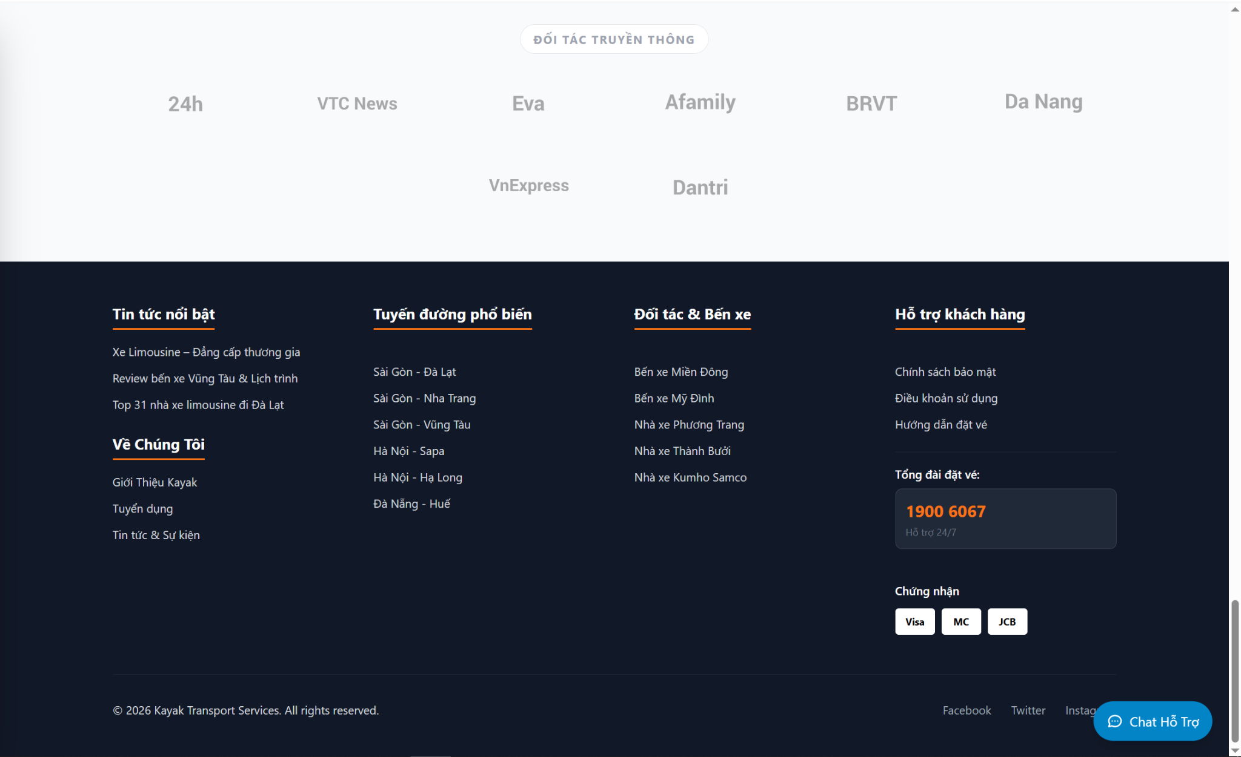

*Figure 14. Footer*

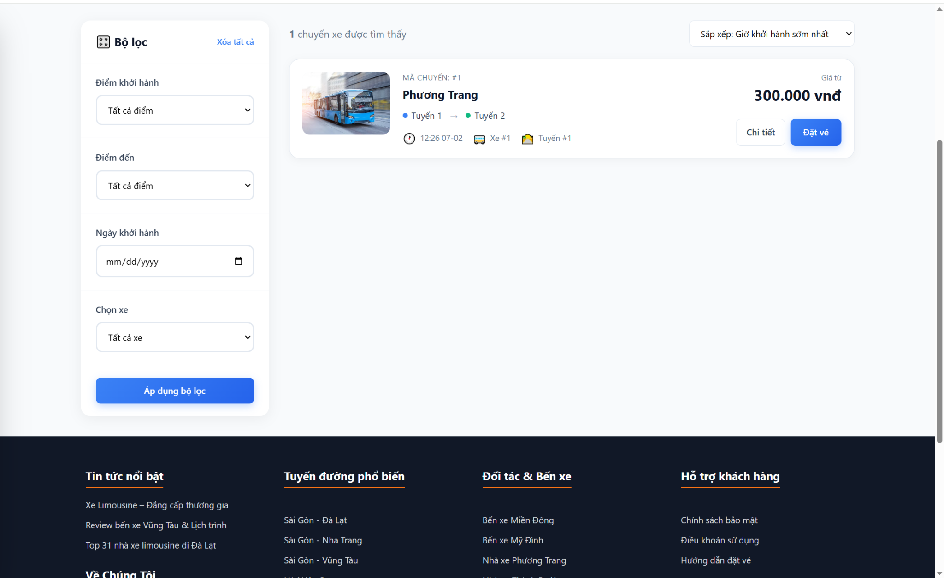

Figure 15. Bus List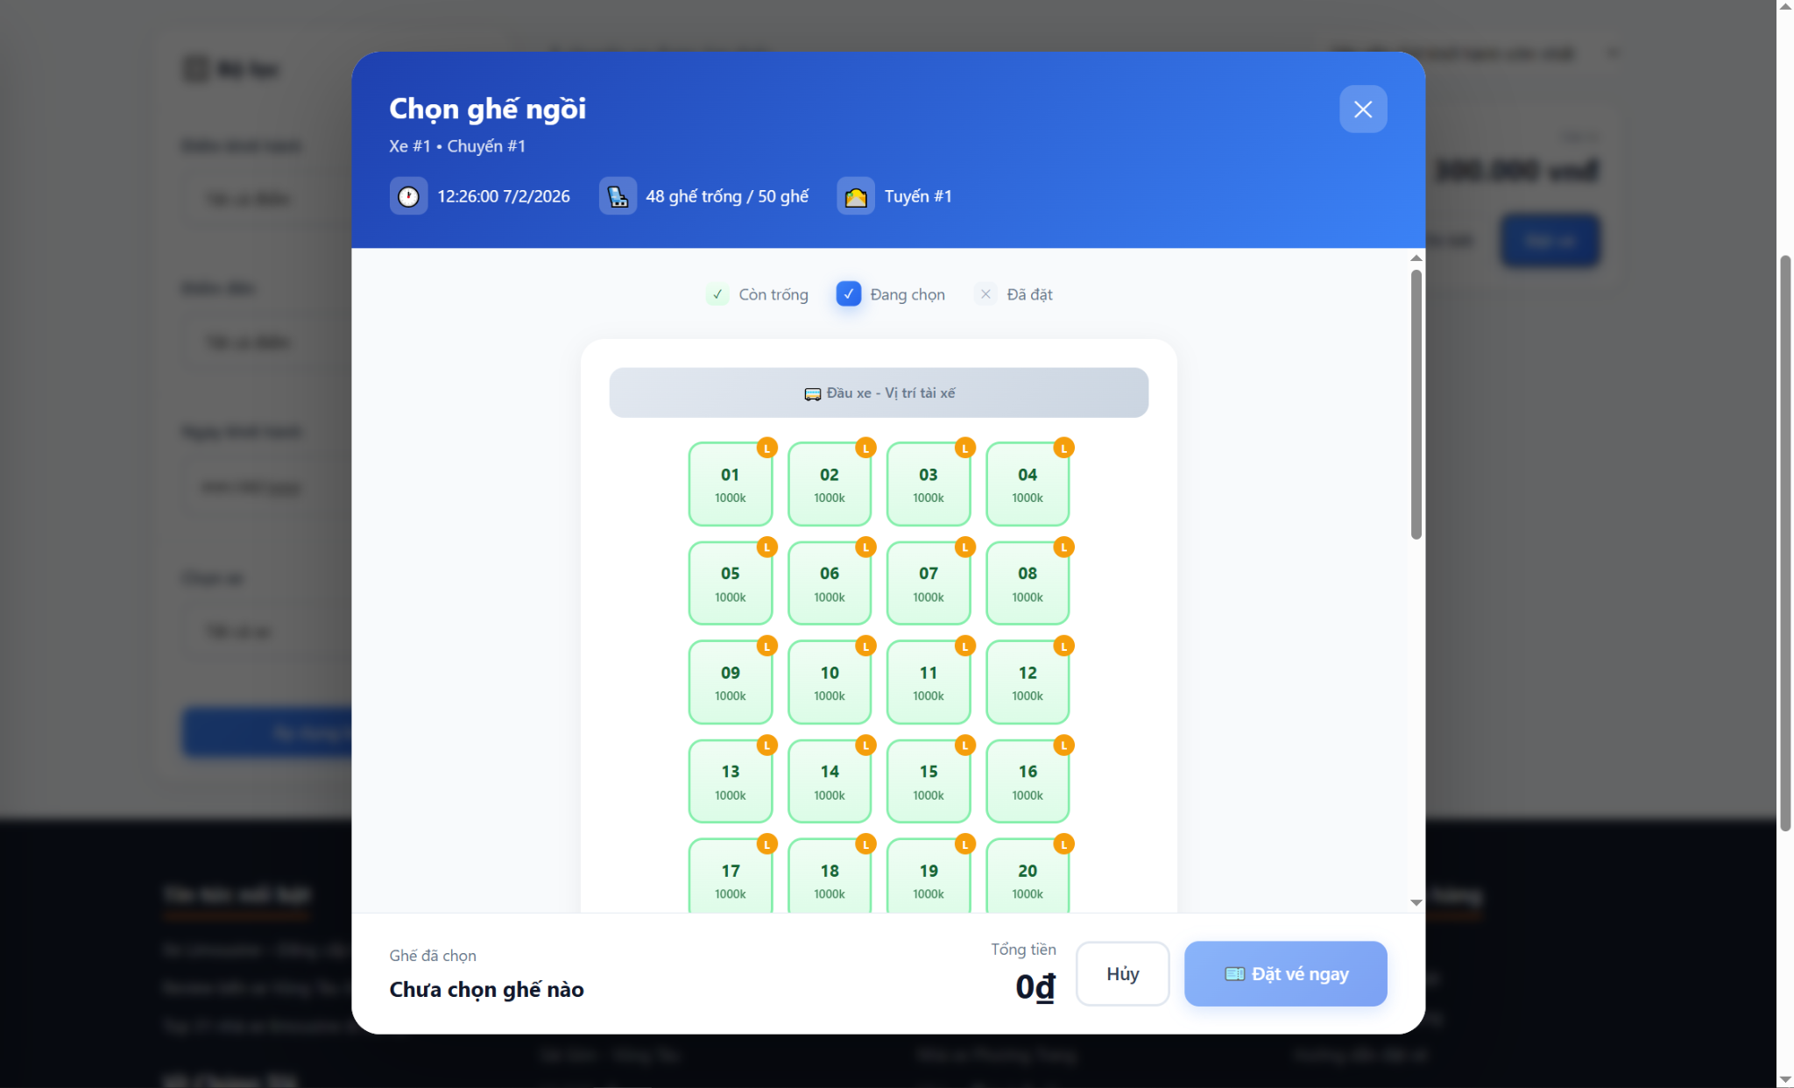Figure 16. Seat Selection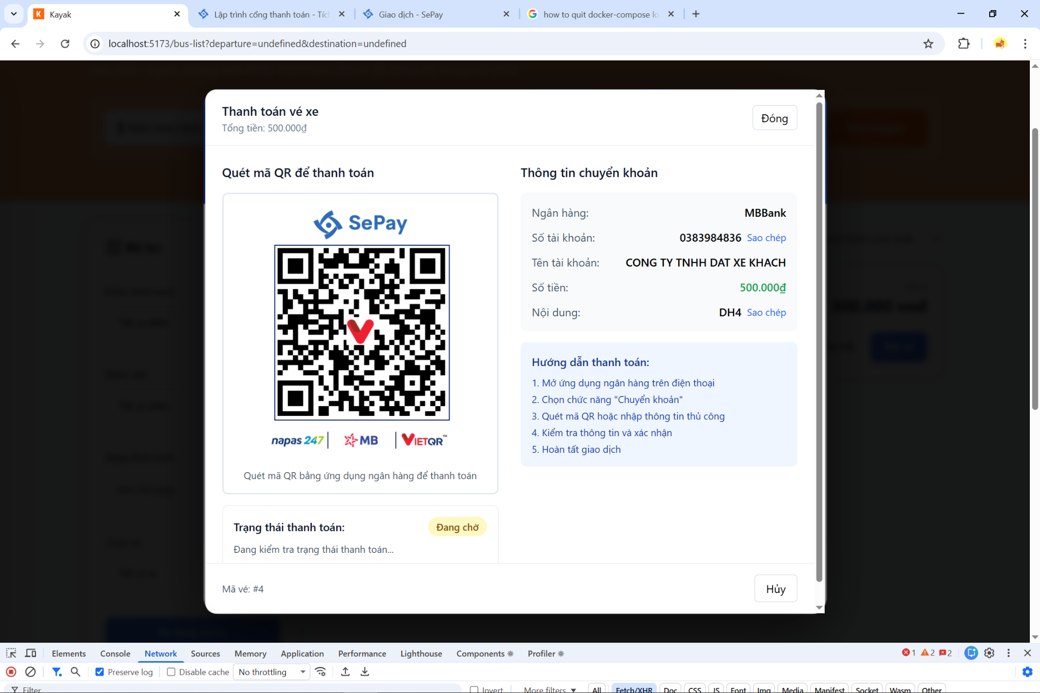

Figure 17. QR Code

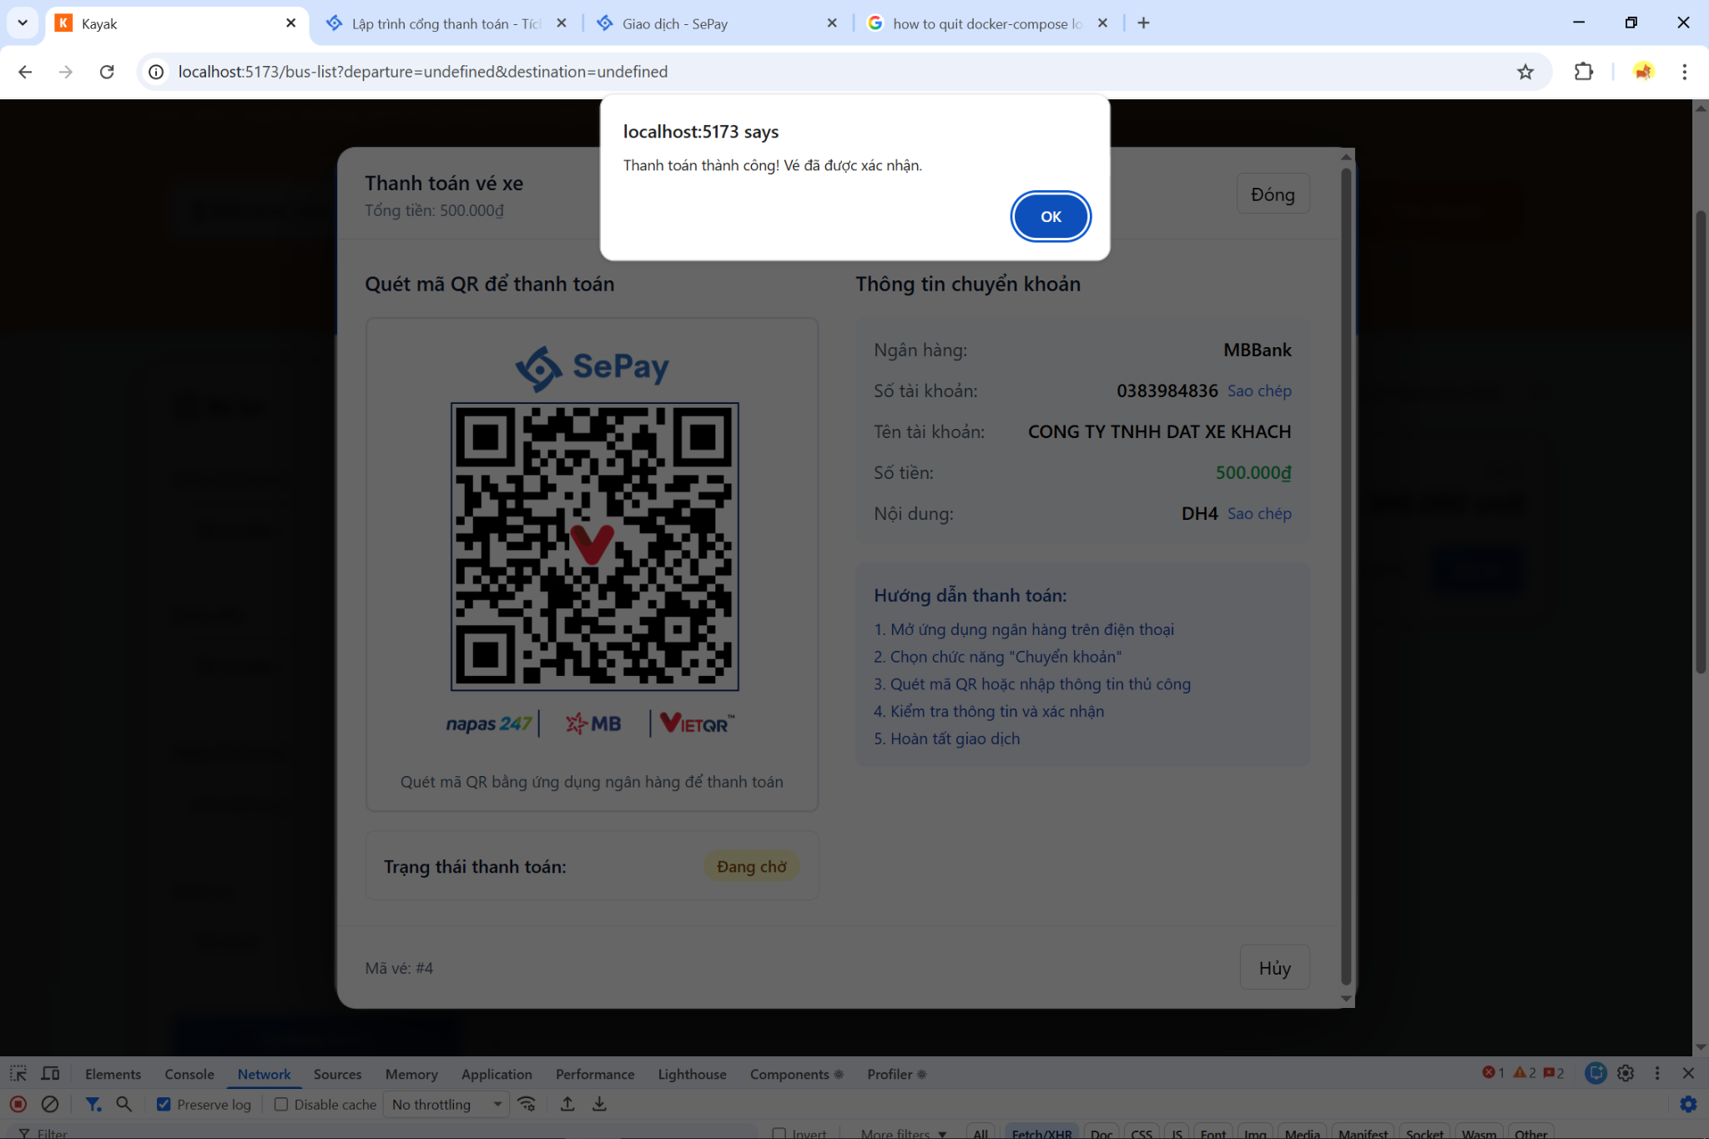

Figure 18. Booking Success

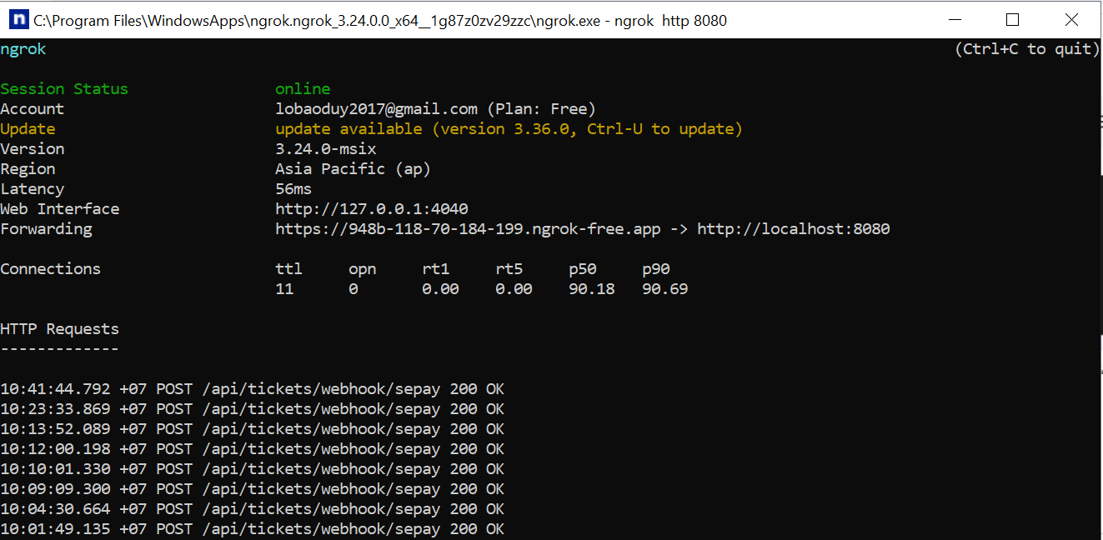

Figure 19. Nginx

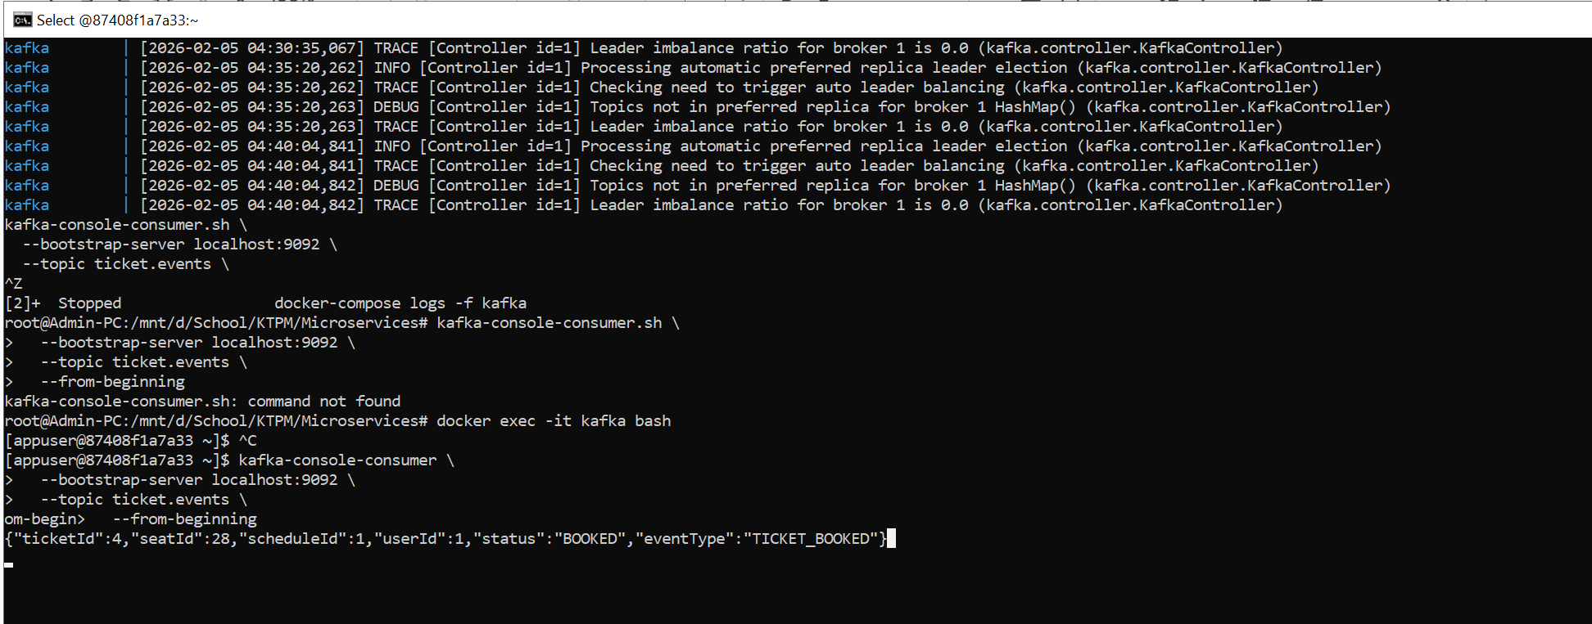

Figure 20. Kafka

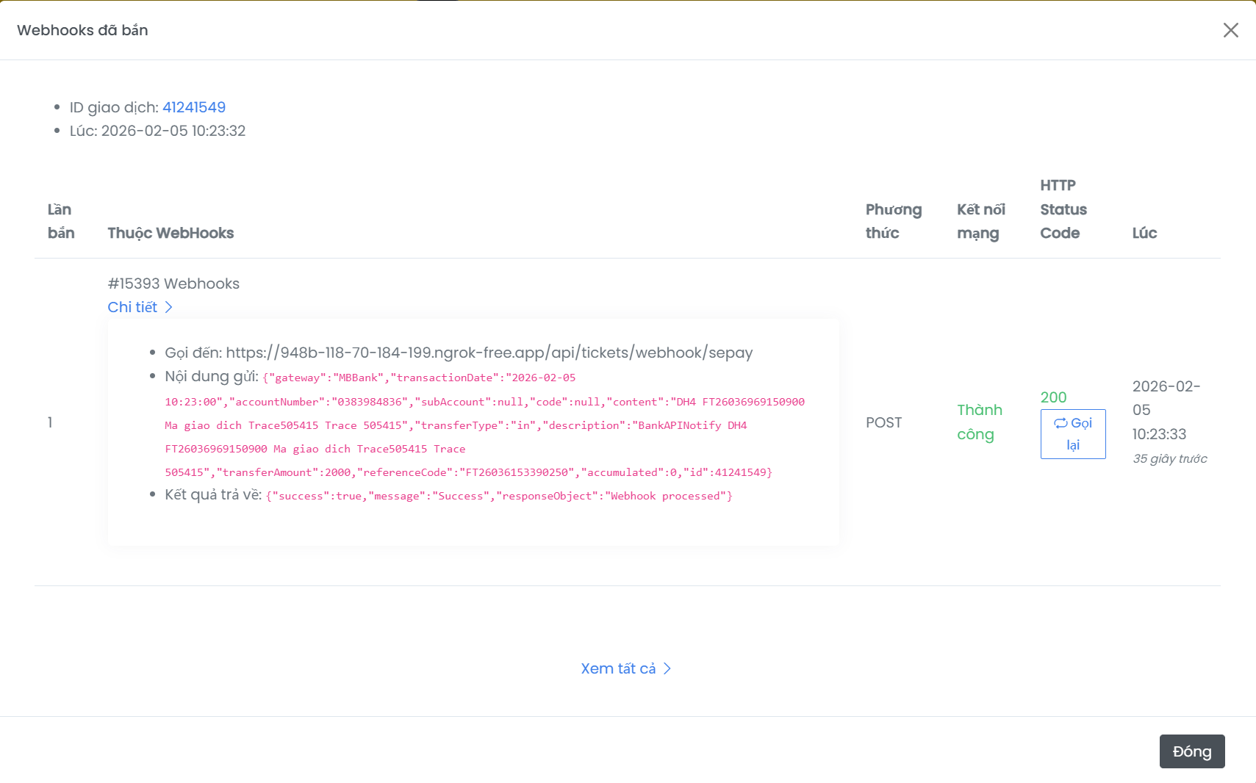

Figure 21. My Tickets_1

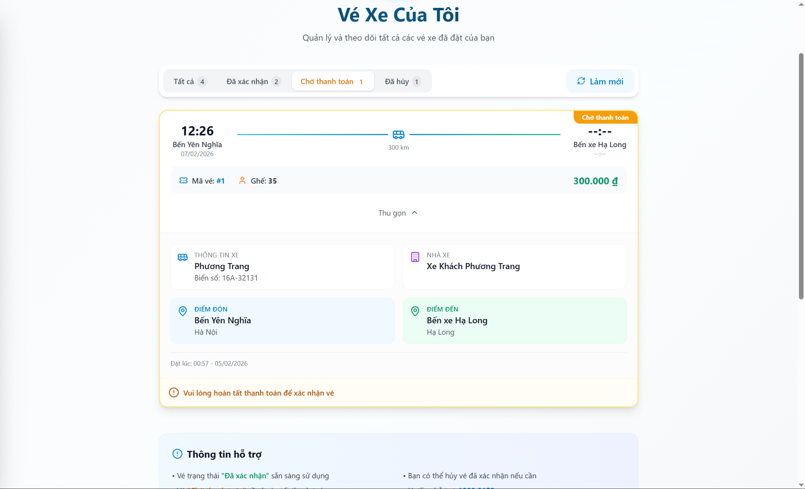

Figure 22. My Tickets_2

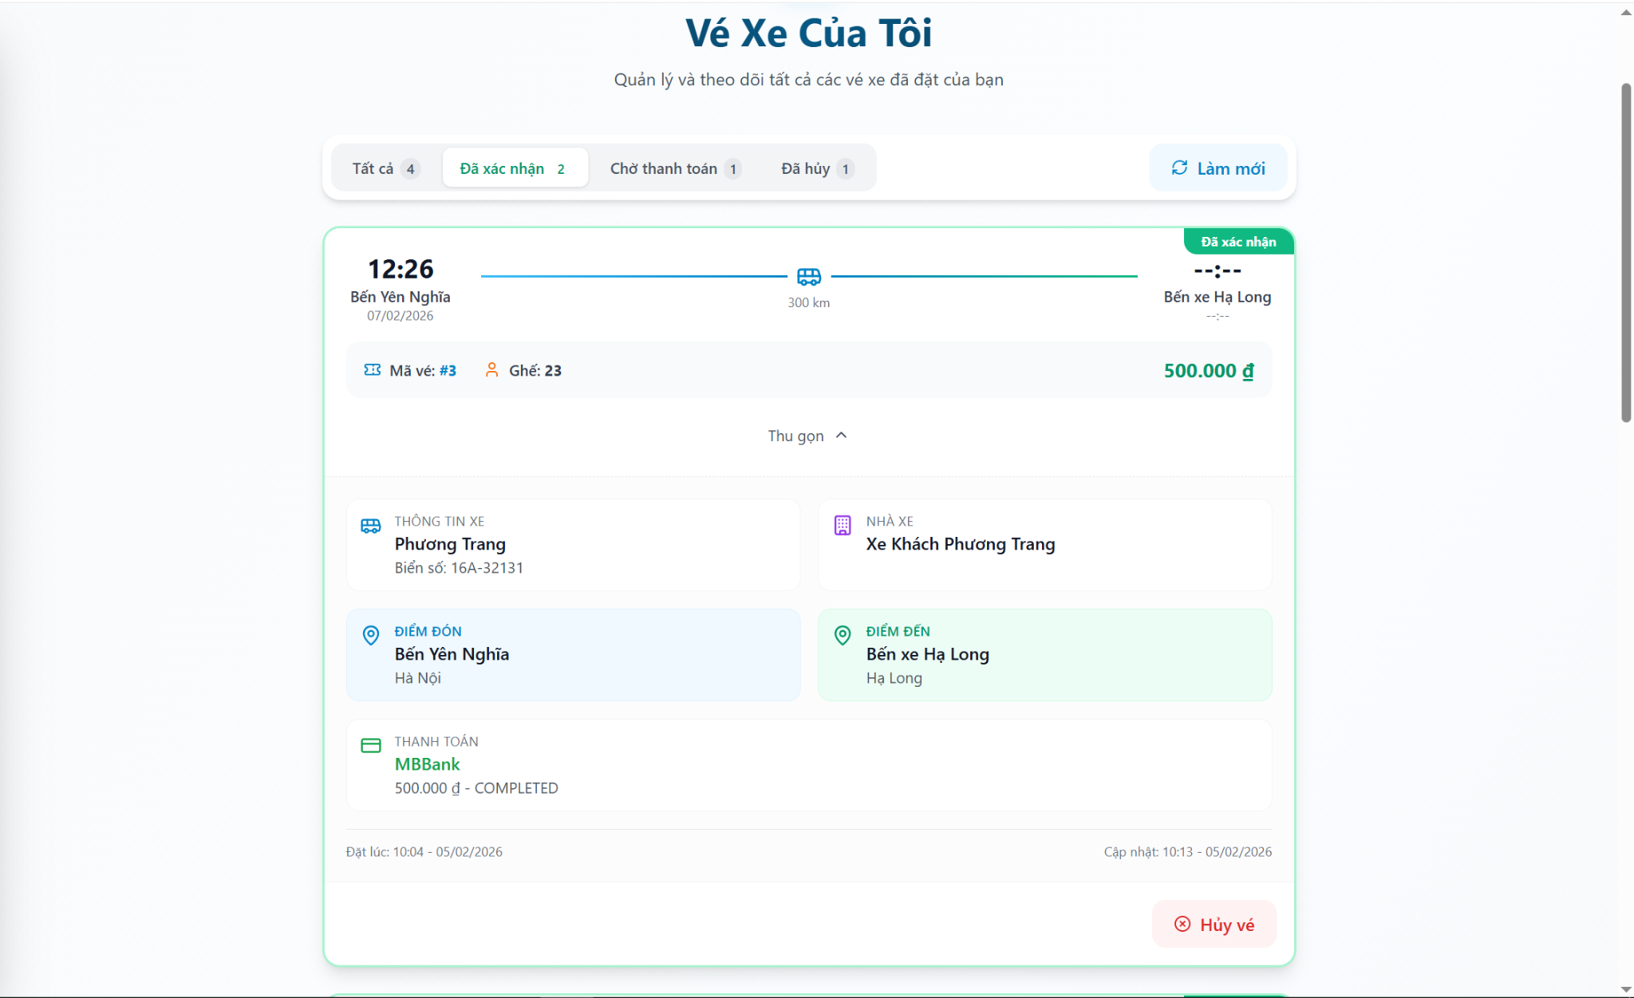

Figure 23. My Tickets_3

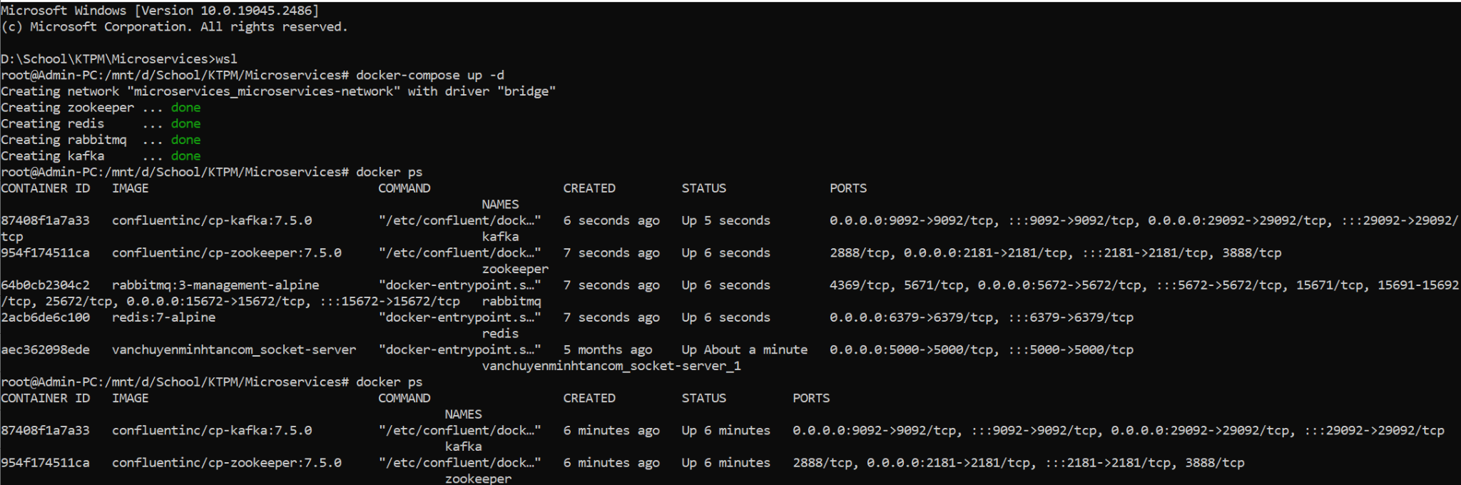

Figure 24. Docker Containers

# 6. Conclusion & Reflection

This project successfully implemented a comprehensive Bus Ticket Booking System using a Microservices Architecture with Event-Driven communication patterns. The architecture demonstrates several key software engineering principles:

**Achievements:**

|  |  |
| --- | --- |
| **Goal** | **Achievement** |
| **Microservices Decomposition** | 6 independent services with clear bounded contexts |
| **Event-Driven Architecture** | Kafka-based async messaging for payment and ticket events |
| **Distributed Locking** | Redis-based seat locking with graceful degradation |
| **API Gateway Pattern** | Centralized routing, authentication, and CORS handling |
| **Clean Architecture** | Layered service structure with separation of concerns |
| **Database Per Service** | Independent MySQL databases per service domain |

## 6.1 Lessons Learned

Microservices Complexity Trade-off: Decomposing the application into services introduces operational complexity (deployment, monitoring, distributed transactions). However, the benefits of independent scaling and deployment outweigh the costs for this use case.

Event-Driven Resilience: Kafka provides excellent decoupling between services. The payment → ticket confirmation flow demonstrates how services can operate independently without synchronous dependencies.

Redis for Distributed State: Using Redis for seat locking proved essential for handling concurrent bookings. The TTL-based expiration mechanism prevents orphaned locks from abandoned sessions.

API Gateway as Security Perimeter: Centralizing JWT validation at the gateway simplifies individual service implementations and ensures consistent security enforcement.

Graceful Degradation: Implementing fallback mechanisms (e.g., Redis lock service accepting requests when Redis is unavailable) improves system resilience.

## 6.2 Future Improvements

|  |  |  |
| --- | --- | --- |
| **Improvement** | **Description** | **Priority** |
| **Service Discovery** | Implement Eureka or Consul for dynamic service registration and discovery instead of hardcoded URLs | High |
| **Circuit Breaker** | Add Resilience4j circuit breakers for fault tolerance in inter-service calls | High |
| **Centralized Logging** | Implement ELK Stack (Elasticsearch, Logstash, Kibana) for aggregated log analysis | Medium |
| **Distributed Tracing** | Add Zipkin/Jaeger for request tracing across services | Medium |
| **Kubernetes Deployment** | Containerize and deploy to Kubernetes for production-grade orchestration | High |
| **Notification Service** | Implement dedicated microservice for email/SMS notifications via RabbitMQ | Medium |
| **Review Service** | Add customer review and rating functionality for bus companies | Low |
| **Chatbot Integration** | Implement AI-powered chatbot for customer support | Low |
| **Payment Retry** | Add retry mechanism for failed webhook deliveries | Medium |
| **Caching Layer** | Implement Redis caching for frequently accessed data (routes, schedules) | Medium |

# REFERENCES

[1] L. Bass, P. Clements, and R. Kazman, *Software Architecture in Practice*, 4th ed. Boston, MA, USA: Addison-Wesley, 2021.

[2] M. Richards and N. Ford, *Fundamentals of Software Architecture: An Engineering Approach*. Sebastopol, CA, USA: O’Reilly Media, 2020.

[3] S. Newman, *Building Microservices: Designing Fine-Grained Systems*, 2nd ed. Sebastopol, CA, USA: O’Reilly Media, 2021.

[4] C. Richardson, *Microservices Patterns: With Examples in Java*. Shelter Island, NY, USA: Manning Publications, 2018.

[5] G. Hohpe and B. Woolf, *Enterprise Integration Patterns: Designing, Building, and Deploying Messaging Solutions*. Boston, MA, USA: Addison-Wesley, 2004.

[6] M. Fowler, “Microservices Architecture,” martinfowler.com, 2014. [Online]. Available: https://martinfowler.com/microservices/architecture.html

[7] S. Newman, “API Gateway Pattern,” *microservices.io*. [Online]. Available: <https://microservices.io/patterns/apigateway.html>

[8] Apache Software Foundation, “Apache Kafka Documentation,” 2025. [Online]. Available: <https://kafka.apache.org/documentation/>

[9] Redis Ltd., “Redis Documentation – Distributed Locks and Caching,” 2025. [Online]. Available: <https://redis.io/docs/>

[10] S. Brown, “The C4 Model for Visualising Software Architecture,” 2023. [Online]. Available: <https://c4model.com/>

[11] OWASP Foundation, “JSON Web Token (JWT) Security Best Practices,” 2024. [Online]. Available: <https://owasp.org/>